Architectural Components - Utility / Helper Modules

📝Definition
# Source: AI Source: Provided by: [Data Path: Persons Table -> ID Column: 1, Name_En Column: Motasem Essam] -> From: [ChatGPT] on [1/23/2026]
Utility or Helper Modules are components that provide reusable functionality used across multiple parts of the system. They don’t hold business logic themselves but support other components by performing common tasks.
👉 Think of them as tools in a toolbox—you grab what you need when building other components.

🔑 Key Points
# Source: AI Source: Provided by: [Data Path: Persons Table -> ID Column: 1, Name_En Column: Motasem Essam] -> From: [ChatGPT] on [1/23/2026]
- Provide common reusable functions
- Should be stateless (no internal state)
- Help avoid code duplication
- Often include: string manipulation, date utilities, file handling, logging, or email sending

❌ Bad Example (No Utility Separation)
# Source: AI Source: Provided by: [Data Path: Persons Table -> ID Column: 1, Name_En Column: Motasem Essam] -> From: [ChatGPT] on [1/23/2026]
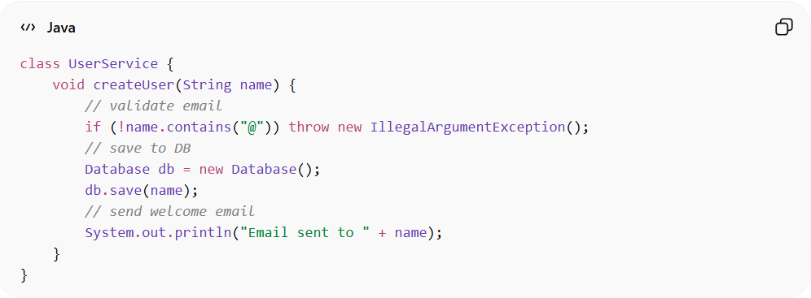
class UserService {
void createUser(String name) {
// validate email
if (!name.contains("@")) throw new IllegalArgumentException();
// save to DB
Database db = new Database();
db.save(name);
// send welcome email
System.out.println("Email sent to " + name);
}
}
👉 Problems:
- Validation, DB access, and email logic all mixed
- Hard to reuse email or validation logic elsewhere

✅ Good Example (Using Utility / Helper Modules)
# Source: AI Source: Provided by: [Data Path: Persons Table -> ID Column: 1, Name_En Column: Motasem Essam] -> From: [ChatGPT] on [1/23/2026]
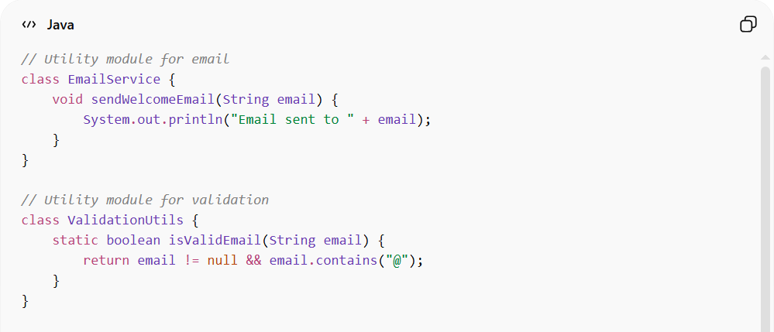
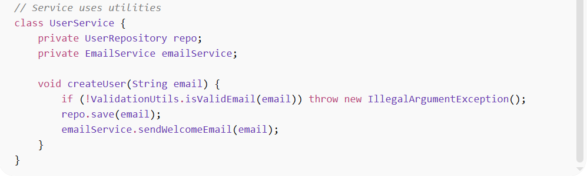

// Utility module for email
class EmailService {
void sendWelcomeEmail(String email) {
System.out.println("Email sent to " + email);
}
}

// Utility module for validation
class ValidationUtils {
static boolean isValidEmail(String email) {
return email != null && email.contains("@");
}
}

// Service uses utilities
class UserService {
private UserRepository repo;
private EmailService emailService;

void createUser(String email) {
if (!ValidationUtils.isValidEmail(email)) throw new IllegalArgumentException();
repo.save(email);
emailService.sendWelcomeEmail(email);
}
}

✅ Benefits
# Source: AI Source: Provided by: [Data Path: Persons Table -> ID Column: 1, Name_En Column: Motasem Essam] -> From: [ChatGPT] on [1/23/2026]
- Reusability: ValidationUtils and EmailService can be used by multiple services
- Testable: Each utility can be tested independently
- Cleaner code: Main service focuses only on business logic

💡 Summary
# Source: AI Source: Provided by: [Data Path: Persons Table -> ID Column: 1, Name_En Column: Motasem Essam] -> From: [ChatGPT] on [1/23/2026]
Utility / Helper Modules support other components by providing reusable tools, keeping your code clean, modular, and maintainable.

